
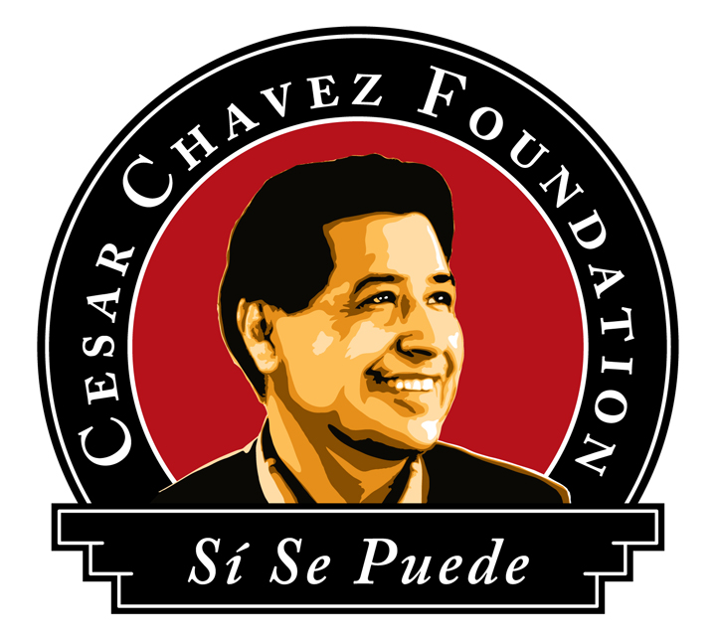
PepsiCo Cesar Chavez
Latino Scholarship

2018-19 Scholarship Application

2016-17

The PepsiCo Cesar Chavez Latino Scholarship is awarding scholarships to students of Latino descent who are beginning or continuing their studies at a higher education institution. The fund provides financial assistance to qualified Latino/a Students in an effort to promote academic success. PepsiCo Cesar Chavez Latino Scholarship Recipients will be honored at the annual Si Se Puede Gala presented by the Cesar Chavez Foundation. Award recipients will be required to complete 30 hours of service to the Cesar Chavez Foundation within 12 months of award.

- General Criteria
Applicant must demonstrate the following: academic excellence, leadership in extra-curricular activities, a commitment to volunteer service in the community, and financial need.

- Eligibility
Applicant must be an incoming or continuing full-time undergraduate student at any education institution for the 2018-2019 Academic Year. Applicant must be of Latino descent. Applicant must have a minimum 3.0 GPA.
Applicant must be attending a college in Arizona or California. The scholarship is available in Arizona and California.
Scholarship is available to U.S. Citizen, Permanent Legal Resident, Undocumented Resident, DACA or Eligible Non-Citizen (as defined by FAFSA). Applicant may only receive award once. Applicant’s immediate family members are not eligible for award within 12 calendar months (e.g. siblings, parents, or children).

- Application Process
Application must be post marked by May 25, 2018.
To be considered for this scholarship, applicants must submit:
- A completed application – typed or printed. Additional pages may be added if space is insufficient. Printed on one side only. Do not staple or paper clip documents.
- Sign and date all pages of the application.
- Submit packet on or before the deadline (postmark will determine compliance). Must be post marked by May 25, 2018. You may send the application packet and any other documentation to the provided address.
- Provide all required documentation (incomplete applications will not be read) in the following order:
  - Application
  - Essay
  - Two (2) Letters of recommendation- include letters in your application packet
  - Official sealed transcripts- schools may send official transcripts separately if needed.
  - A copy of the Student Aid Report (SAR). The SAR may be obtained from your FAFSA.
    - If you do not qualify for FASA, please contact the Scholarship Fund for the Alternative Proof of Income/Financial Form at scholarship@chavezfoundation.org. Please provide a copy of the first two pages of your most recently filed IRS Form 1040. If you have not filed an IRS Form, please submit a copy of your most recent W-2 form, if available or a letter from your employer.
  - If you are financially dependent on your parents, please submit a copy of the first two pages of your parent’s most recently filed IRS Form 1040. If they have not filed an IRS Form, please submit a copy of their most recent W-2 forms, if available.
    - If you are financially independent, please provide a copy of the first two pages of your most recently filed IRS Form 1040. If you have not filed an IRS Form, please submit a copy of your most recent W-2 form, if available.

The application and documentation must be postmarked and mailed by the deadline. Please mail to the following address as written:
PepsiCo Cesar Chavez Latino Scholarship
1655 E. California Ave, Leasing Office
Bakersfield, CA 93307

For any questions on this application, please email: scholarship@chavezfoundation.org

 | ALL INFORMATION WILL BE KEPT STRICTLY CONFIDENTIAL
 | PERSONAL INFORMATION
 | Last Name |  |  |  |  |  |  |  |  |  |  |  |  | First Name |  |  |  |  |  |  |  |  |  |  |  |  |  |  | Middle Initial
 | Permanent Address: Street Address |  |  |  |  |  |  |  |  |  |  |  |  | City |  |  |  |  |  |  |  | State |  |  |  |  |  |  | Zip Code
 | Campus Address: Street Address |  |  |  |  |  |  |  |  |  | City |  |  |  |  |  |  |  |  |  |  | State Zip Code
 | E-mail Address |  |  |  |  |  |  | Permanent Phone Number |  |  |  |  |  |  |  |  |  |  |  |  |  | Cell Phone Number
 | Date of Birth Age Place of Birth
 | EDUCATIONAL INFORMATION
2018-2019 Enrollment Status: Incoming Freshman Junior Student 1st year Generation College Student

Sophomore Student Senior Student Full Time Student (12 units)
 | High School Attended (Name & City) |  |  |  |  |  |  |  |  |  |  | Dates of Attendance/Graduation |  |  |  |  |  |  |  |  |  |  |  |  |  | High School Weighted GPA
 | Junior College Attended (Name & City) |  |  |  |  |  |  |  |  |  |  | Dates of Attendance/Graduation |  |  |  |  |  |  |  |  |  |  |  |  |  | Junior College Weighted GPA
 | Vocational College Attended (Name & City)  Dates of Attendance/Graduation College GPA |  |  |  |  |  |  |  |  |  |  |  | Dates of Attendance/Graduation |  |  |  |  |  |  |  |  |  |  |  |  |  | College GPA
 | Name of College Attending in 2018-2019 (Name & City)
 | Major (Intended/Declared) Are you a transfer student? What college did you transfer from?
 | HONORS AND AWARDS
List all honors and awards demonstrating scholastic and leadership achievement.
Please attach a copy of most recent transcript.
 | Honor/Award Name & Year |  |  |  |  |  |  |  |  |  |  |  |  |  |  |  |  | Description (Include nature and level of competition)
 | SCHOOL/EXTRACURRICULAR ACTIVITIES
List all school activities in which you have participated during the past 3 years (e.g. student government, music, sports, etc.).
List all leadership positions and offices held.
 | Activity |  |  | Dates of Involvement |  |  |  |  |  |  |  |  |  |  | Description |  |  |  |  |  |  |  |  |  |  |  |  |  |  | Position/Office Held
 | Applicant’s Name:
 | (Last) (First) (Middle Initial)
 | COMMUNITY/VOLUNTEER SERVICES
List all community and volunteer activities in which you have participated during the past 3 years and the number of service hours you completed. (e.g. Big Brother/Big Sister, Youth Group, volunteer at nursing homes, etc.).
List all leadership positions and offices held.
 | Activity # of Hour  Volunteered |  |  |  | Dates of Involvement |  |  |  |  |  |  |  |  |  | Description |  |  |  |  |  |  |  |  |  |  |  |  |  |  | Position/Office Held
 | EMPLOYMENT/WORK EXPERIENCE
 | List all employment/work experience held during the past 3 years (indicate if paid position or internship)
 | Name of Employer |  | Address |  |  |  |  |  |  |  |  |  |  |  |  | Position |  |  |  |  | Dates of Employment |  |  |  |  |  |  |  |  |  | Hours per Week |  |  |  | Wage per Hour
 | Applicant’s Name:
 | (Last) (First) (Middle Initial)
 | FINANCIAL INFORMATION
List scholarships and grants received from a college during the last year, as well as the upcoming school year.
If applicant is an incoming freshman or transfer student, list scholarships or grants anticipated for the 2018-2019 school year.
 | Year |  |  |  |  |  |  |  |  | Scholarship Amount |  |  |  |  |  |  |  |  |  |  |  |  | Grant Amount
 | 2017-2018 |  |  |  |  |  |  |  |  | $ |  |  |  |  |  |  |  |  |  |  |  |  | $
 | 2018-2019 |  |  |  |  |  |  |  |  | $ |  |  |  |  |  |  |  |  |  |  |  |  | $
 | List all scholarships/grants received this year |  |  |  |  |  |  |  |  | $ |  |  |  |  |  |  |  |  |  |  |  |  | $
 | FAMILY BIOGRAPHICAL INFORMATION
 | Father’s Name:
 | Last |  |  |  |  |  | First |  |  |  |  |  |  |  |  |  |  |  |  | Place of Birth
Current Occupation # of Years Previous Occupation # of Years

Provide the Annual Gross Income Bracket (refer to 1040 or W-2 forms):
 | <$10,000 | $10,000-20,000 |  |  |  |  |  | $20,000-30,000 |  |  |  |  |  |  |  |  | $30,000-40,000 |  |  |  |  |  |  | $40,000-50,000 |  |  |  |  |  |  |  |  |  | >$50,000
 | Provide the Highest Educational Attainment:
 | Doctoral Degree |  |  |  |  | Master’s Degree |  |  |  |  |  |  |  |  |  |  |  |  | Bachelor’s Degree |  |  |  |  |  |  |  |  |  | Associate / 2-Year Degree
 | Some College |  |  |  |  | High School Graduate |  |  |  |  |  |  |  |  |  |  |  |  | Some High School |  |  |  |  |  |  |  |  |  | Jr. High / Elementary
 | Mother’s Name:
 | Last |  |  |  |  |  |  |  | First |  |  |  |  |  |  |  |  |  |  | Place of Birth
Current Occupation # of Years Previous Occupation # of Years

Provide the Annual Gross Income Bracket (refer to 1040 or W-2 forms):
 | <$10,000 | $10,000-20,000 |  |  |  |  |  |  | $20,000-30,000 |  |  |  |  |  |  |  | $30,000-40,000 |  |  |  |  |  |  | $40,000-50,000 |  |  |  |  |  |  |  |  |  | >$50,000
 | Provide the Highest Educational Attainment:
 | Doctoral Degree |  |  |  |  | Master’s Degree |  |  |  |  |  |  |  |  |  |  |  |  | Bachelor’s Degree |  |  |  |  |  |  |  |  |  | Associate / 2-Year Degree
 | Some College |  |  |  |  | High School Graduate |  |  |  |  |  |  |  |  |  |  |  |  | Some High School |  |  |  |  |  |  |  |  |  | Jr. High / Elementary
 | Are you a first generation college student? Y N |  |  |  |  |  |  |  |  |  |  |  |  |  |  |  |  |  | Living Household Size:  (Total Number of Persons including you)
 | Number of Siblings: |  |  |  |  |  |  |  |  |  |  |  |  |  |  |  |  |  | Number of Siblings in College:
 | Are you a dependent or independent student? |  |  |  |  |  |  |  |  |  |  |  |  |  |  |  |  |  | Citizenship Status (confidential):
Applicant’s Name:
(Last) (First)

ESSAY
You will be assessed on your ability to answer the following questions. Please be thoughtful and answer the questions directly. Please attach your response to the following essay at the end of this application.
The essay shall be limited to 500 words, typed and double-spaced. Make sure to number each page of the essay.

“The end of all education should surely be service to others.” – Cesar Chavez

Explain how does the statement above apply to your life.
Explain how have you exemplified or plan to exemplify this statement in your life goals.
Provide your thoughts on what you believe service to others means in todays society.

 | LETTERS OF RECOMMENDATION
 | Two signed letters of recommendation are required. They must be sealed. One letter must be written by a teacher/professor from your current school. The second letter must be written by a job supervisor/community leader for whom you have worked/volunteered. Please make sure to provide the two different types of letters.
 | Please identify individuals who will be submitting letters of recommendation on your behalf:
 | Name |  |  |  |  |  |  |  |  |  |  |  | Teacher/Professor-Position/Title |  |  |  |  |  |  |  |  |  |  |  |  |  |  | Telephone Number
 | Name Job Supervisor/Community Leader-Position/Title Telephone Number
 | All letters of recommendation shall include your name as it appears on this application. In addition, the letter must include the following:
- Address the length and relationship to the applicant.
- The applicant’s strengths and weaknesses.
- The applicant’s academic or work achievements and contributions to the community.
- The applicant’s potential for success.
- Any impediments or hardships of which you are aware that the applicant has had to overcome to achieve success.
- The applicant’s motivation and initiative in pursuing academic career goals.
 | CERTIFICATION
 | I certify that the information in this application is true, complete, accurate, and that all statements and essays are my own work. The PepsiCo Cesar Chavez Latino Scholarship may be denied or revoked if any information is found to be incomplete or inaccurate. Should I receive a grant, I give permission to the Scholarship to 1) Utilize my name, picture, and grant amount in any publicity or marketing materials and 2) Release my name, address, phone number, and email address to the individual donor or group who funded my grant. I also understand my commitment to completing my 30 hours of service to the Cesar Chavez Foundation, if I am chosen as one of the Scholarship Recipients.
 | Signature of Applicant (in ink) Date

